**.Student Names:**

**Sri Chundu,Adithya Raju, Manbir Kaur, Aakash Kodolikar**

**CP5046 ASSESSMENT TASK 1: Project Documentation**

This assessment task has been prepared by Dr. Dmitry Konovalov for James Cook University. Updated 22 April 2020.

**© Copyright 2019**

This publication is copyright. Apart from any fair dealing for the purpose of private study, research, criticism, or review as permitted under the Copyright Act, no part may be reproduced by any process or placed in computer memory without written permission.

**ASSESSMENT TASK 1: PROJECT DOCUMENTATION**

|  |  |
| --- | --- |
| **Aligned subject learning outcomes** | All |
| **Group or individual** | Group |
| **Weighting** | 20% |
| **Due date** | Week-7 Friday 9am 12-Apr-2019 |

**ASSESSMENT TASK 1: DESCRIPTION**

This task is the ***iteration-1*** in terms of the Agile Software development. It defines the initial project specifications including goals, deliverables, and planning for ***iteration-2*** (***alpha release***).

**ASSESSMENT TASK 1: CRITERIA SHEET**

**[_____/20 marks] Assignment is done in a group with 2-4 students.**

***Every team member gets the same mark for this assessment item***

Write group members here:

|  |  |  |
| --- | --- | --- |
| **Student Number** | **Student Name** | **Project Role** |
| 1 | Adithya Raju | Data Collection, Data Analysis, Content Management. |
| 2 | Sri Chundu | Development tools, Testing,Prototypes Design, Client Agreement. |
| 3 | Manbir Kaur | Project description, Market research, Target audience, User story, Configuration management. |
| 4 | Aakash Kodolikar | Design app using Android Studio |

**[____/Prerequisite for marking]** Assignment is completed using an electronic copy of ***this*** document and submitted to LearnJCU electronically.One submission per team.

**[_____/20 marks] Project description for non-ICT-technical stakeholders and general audience.** Write here: minimum **TWO** pages, maximum **TEN** pages.

**Project Description**

**Justification for project**

Violence against women in all over the world where it’s referred to physical or sexual violence committed against Indian women, typically by a man. Common forms of violence against women include acts such as domestic abuse, sexual assault, and murder. In order to be considered violence against women, the act must be committed solely because the victim is female. Most typically, these acts are committed by men as a result of the long-standing gender inequalities present in the country. After a few analysis of feedback from various stakeholders/ NGOs/ Women Organizations/and the complainants themselves as well as taking into consideration. The main aim behind the development of WomenSaver is to prevent and spread awareness about the crime held by the offenders. In addition to this, this web based application will provide different prevention ideas so that women can prevent themselves. The WomenSaver site encourages women to share their problems and at the same time, safeguard their identity. WomenSaver is a web application that helps women who have been gone through any criminal activity by prisoners. The data collected from different authenticated sources. WomenSaver will collect the data from different sources and apply mining on that dataset, fetch the result and upload it into our site. This is how we work.

**Market Research**

There are many sites available related to crime against women where one can register their crime and can get the help from that site. Here, this app will give you the guideline for the crime against women, how to prevent the crime, and what measure should be taken by the government so the prisons can be stopped/ reduced. From available apps, some features are extracted which are

1. Database: Contains the different year’s database of crime against women for a particular city.

2. Register: The one who faced any type of harassment can register the crime.

In our system, we are going to apply the data mining technique which helps us to find out which criminal activity against women was held on which particular period of time. And that result will be uploaded into our site so that any woman and government can take precautions before it has done.

**Target audience**

The main target visitors of our App are women or any citizen of the nation who wants to learn about crime against women and take tips to prevent the family from such kind of criminality.

**Project details**

The main purpose of WomenSaver is to acknowledge the people around the world about criminal activity against women and which steps should be taken to stop the offence. Many women and other people are there in the world who do not have knowledge about this type of crime. So, this website may help them to grow their knowledge and can take precautions before it can be done by offenders.

There are main two roles are provided:

1. Admin: Admin person is able to add and remove the data from the website.

2. Visitor: Visitor can see the data uploaded by the admin.

**Justification**

Alpha release: In our alpha release, there are more admin related user stories than the user side. Here, in phase 1 of the project, admin related general user stories will be developed. Whereas, we will develop general applications for users.

Beta release: This is a significant phase for our team that we are going to create a full admin side user stories, including some essential user side user stories. In the second phase, we will focus more on managing the admin department.

.

|  |  |
| --- | --- |
| **Goal Number** | **Goal Description** |
| 1 | Home : this is the home page and most of the interactions will take place here. Here the visitors will land on this page. |
| 2 | Navigation : In order for visitors to roam around and explore other functions of the app. |
| 3 | Database : In order for login and sign up, we need databases to store the content. There are different types of databases and depending upon the data that we shall be taking in we will consider the database type. (Relational and Operational) |
| 4 | Notification : People need to be informed about the updates and thus notifications are a means to do so. |
| 5 | Redirection : If a person wants to know more about any of the information we have they can do so on the redirected content page. |

**[_____/20 marks] Project scope of the full final release (Project audit at the end of CP5047 subject). Clearly specify the scope of alpha release (Project audit at the end of CP5046 subject), and w**rite here: Minimum **TWO** pages, maximum **TEN** pages.

**Available days:** PASS-level (minimum) effort is 1-day and maximum are 3-days per teaching week (assume 12 weeks per study period), per team member. For example: 12 x 2 = 24 days is the minimum for a team with 2 students, 12x2x3=72 days is the maximum. The available days must match the SUM of your user story estimates below.

User story 1: title, short description, effort estimate (in days, maximum of 5 days).

User story 2: ...

|  |  |  |
| --- | --- | --- |
| **User Story Title** | **User Story Description** | **Effort Estimate** |
| Homepage | As a user, I need a homepage/landing page so that I can browse/view the popular/featuring content of the web App | 5 Days |
| Categorized view | As a user, I need a categorized view of app so I can view content as per categories. | 5 Days |
| Navigation | As a user I need a navigation bar so I can navigate to different pages on the app from one place and browse more efficiently on the app. | 6 Days |
| Sign Up | As a user, I need a sign up page so that I can register on the app as a new member | 4 Days |
| Log In | As a user, I need a login page so that I can log in on the app in my members account | 4 Days |
| View content page | As a user, I need a content viewing page so that I can view any content that I click on the app on a separate page. | 4 Days |
| Creating a database | As an admin, I need a database management system so that I can manage all the data of my app. | 6 Days |
| Database of Admin | As an admin, I need a database of admins so that I can view and authorise all the admins of my app. | 6 Days |
| Database of users | As an admin, I need a database of users who are registered to the app so that I can manage all the users of the app. | 4 Days |
| Notification | As a user, I need a notification system in the app so that I can be notified about appropriate activities on the app. | 4 Days |

**[_____/20 marks] Project sponsor/client/customer signed/agreed to the scopes of the alpha-release and the final-release.** Cut/Paste clients’ email here, or show signed the preceding “**Project scope**” to your marking lecturer.

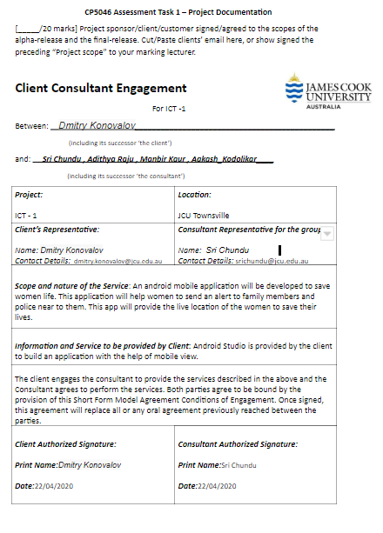

**[_____/20 marks] Project development and release ICT infrastructure.** This must include development environment, programming languages, source code repositories (Configuration Management), project collaboration tools, and development tools. Write here: minimum **TWO** pages, maximum **TEN** pages.

· [___/5 marks] **Configuration Management**/version control, e.g. git, GitHub, Heroku, bitbucket;

GitHub: The version control tool GitHub is used here to host the code so that all other team members can access the code. It is the world’s most usable and open source online repository where programmers can put their work. GitHub stores all necessary data of the project, such as documentation of the tool, configuration file, and some major logs of the project. The workspace in the GitHub includes the code of the project. Commits in the GitHub is useful for each team member, and it is used to add or remove the code from the repository. Commits are divided into two parts, like staged and unstaged commits. Each of these has its unique use, where staged commits are verified and can be added into the repository directly whereas unstaged commits are not verified. Branches are used when a person is working on the same project but on a different version of the project without interrupting the main line of the project.

· [___/5 marks] **Project tools**. Programming languages/IDEs, e.g. php/WebStorm, java/IntelliJ; Building tools/procedures, e.g. git-push to Heroku; e.g. how-to set-up your development environment for a new team member.

1. **Programming language Java**: We are using Java as a back-end programming language for our application. Java is a most commonly used language. We can keep running on android studio so there is a fascinating reason to recompile for various mobile devices, better security, numerous advanced tools accessible for java(Gupta,2018).
2. **Android studio**: Our application is an android app,hence we are using Android studio 7 as the IDE.Android Studio is the official integrated development environment ([IDE](https://searchsoftwarequality.techtarget.com/definition/integrated-development-environment)) for Android application development. It is based on the [IntelliJ IDEA](https://www.theserverside.com/definition/IntellJ-IDEA), a [Java](https://www.theserverside.com/definition/Java) integrated development environment for software, and incorporates its code editing and developer tools.It is purpose built for Android to accelerate our development and help to build the highest-quality apps for every Android device. It offers tools custom-tailored for Android developers, including rich code editing, debugging, testing, and profiling tools.
3. **GitHub**: We are using GitHub as version control.Version control systems keep these revisions straight, storing the modifications in a central repository. This allows developers to easily collaborate, as they can download a new version of the software, make changes, and upload the newest revision. Every developer can see these new changes, download them, and contribute.

· [___/5 marks] **Testing** tools, data and procedures (what and how you are planning to test), e.g. junit; Client testing and access to release, e.g. domain name, domain hosting; Client training document, and procedures; Release testing tools, data and procedures (what and how you are planning to test).

Testing and development is one of the later parts of this project. All of our project tests will be performed on an android device (handheld) using Android Studio.

Once the application is connected appropriately with the interfaces, the testing procedure will be done in order to check whether the app is functioning properly or not. This testing will be done with our client who will check the functioning of the app and see how good it is and can tell what are the new features added to this application. The client will also test how the helpline numbers and alert signs can perform their tasks in times of emergency. If the client has any issues regarding the app, according to the changes the app will be improved in order to function more efficiently and helpful for women who are in need of help. Before the final launch of the app, based on the clients reviews, we will make necessary changes.

· [___/5 marks] **Prototypes are demonstrated to justify the proposed ICT solutions**.

1. LogIn:

Once the user is registered with the app, the user can login by providing the credentials.

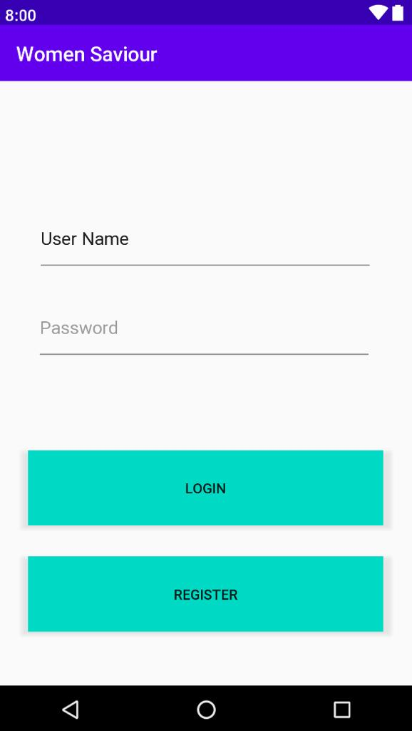

1. Sign Up:

In order to register with the app, the user needs to provide personal details such as Name and Email Id and confirm the details.

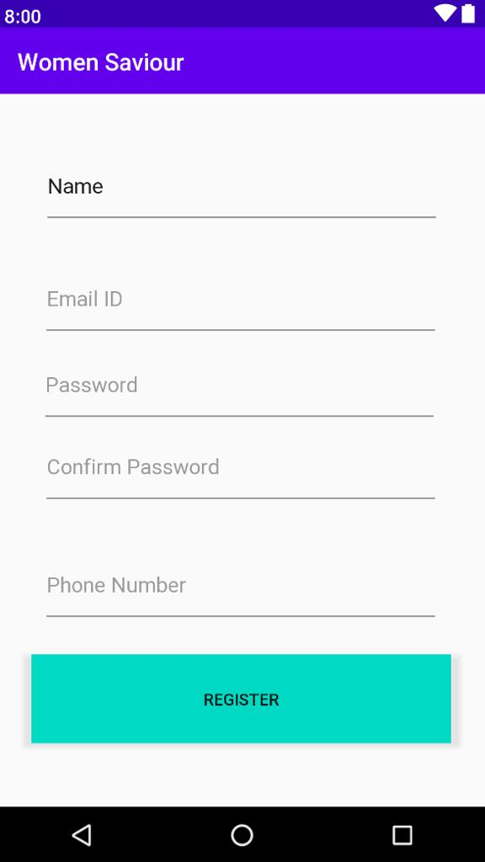

1. Emergency Contact:

This page is designed for the user to provide emergency contact with family or

friends in order to send alerts when they are in emergency.

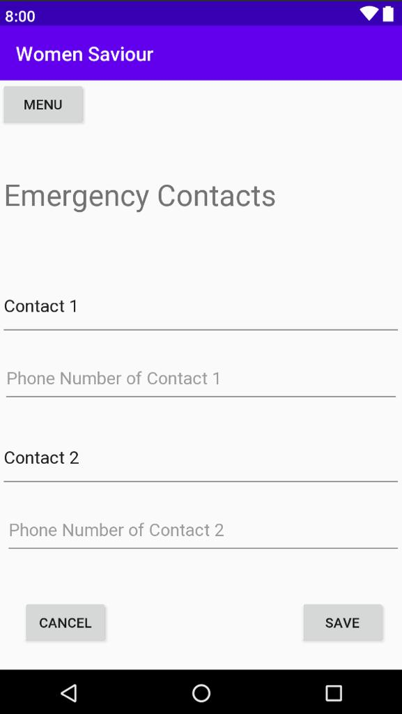

1. Home Map:

This is the home page. Here a map pointing to your location will be shown. Along with the map there are 4 buttons to choose from, Menu, Panic, Mark safe and Alert. All of these have different functionalities. Menu displays the navigation drawer. Panic button calls 000 and/or 112, alert button alerts your emergency

contacts and mark safe conveys your contacts that you are safe and sound.

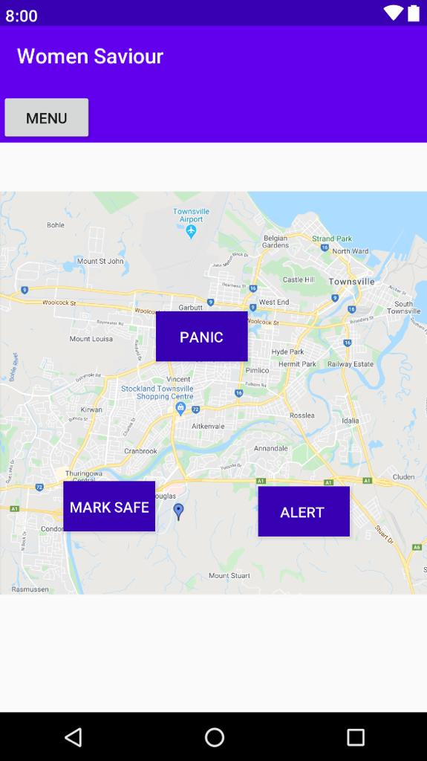

1. Emergency Alert:

From the above page when the user clicks on the alert button, the page will be directed for the user to send an emergency sms or create an sms. Once the user selects to send emergency sms, an automatic message will be sent to the police and family members.

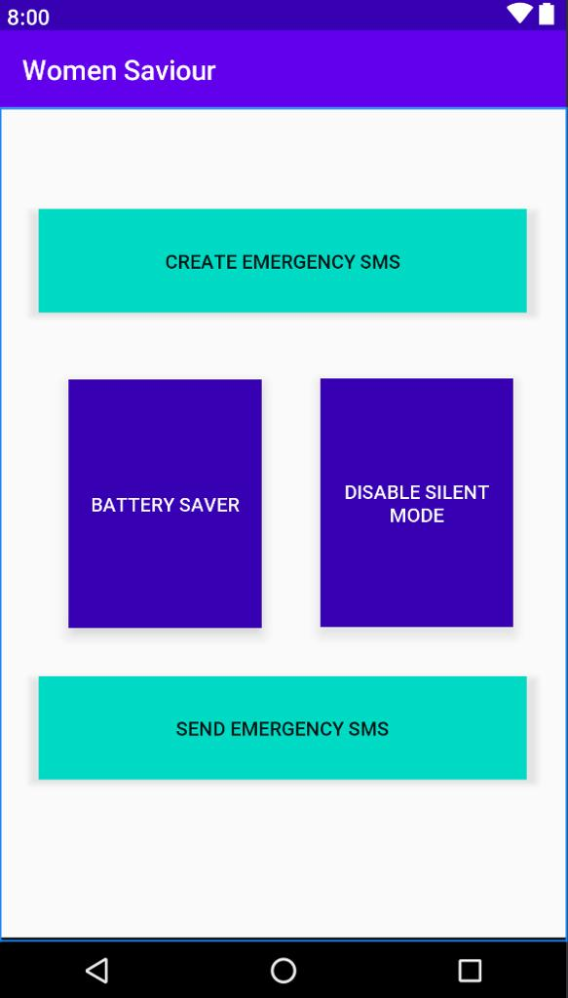

1. Alert Message:

When the user clicks on the send emergency sms, the page will be redirected to the setting page in which the user can find an automatic message.

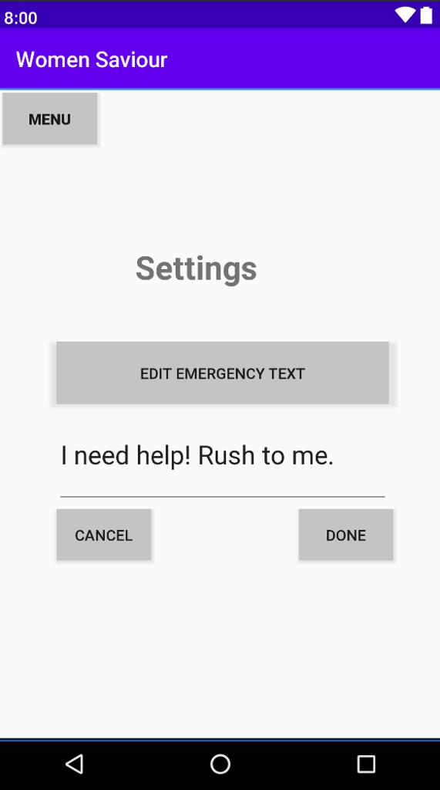

REFERENCES

* Walter, D. (2018, October). What is Android Studio? - Definition from WhatIs.com. Retrieved from<https://searchmobilecomputing.techtarget.com/definition/Android-Studio>
* Gupta, L. (2018, December 27). What is Java programming language? Retrieved from<https://howtodoinjava.com/java/basics/what-is-java-programming-language/>
* Courtemanche, M. (2018, June). What is GitHub? - Definition from WhatIs.com. Retrieved from https://searchitoperations.techtarget.com/definition/GitHub